DELIVERYOF SPRINT– 1

|  |  |
| --- | --- |
| **DATE** | 22NOVEMBER 2022 |
| **TeamID** | PNT2022TMID06240 |
| **PROJECTNAME** | SMART WASTE MANAGEMENT FORMETROPOLITANCITIES-IOT |
| **STORYPOINTS** | 20 |

**FunctionalRequirement**–Signin/Signup **Userstory:USN–1HTMLCODE**:

<!DOCTYPEhtml>

<htmllang="en">

<head>

<metacharset="UTF-8"/>

<metaname="viewport"content="width=device-width,initial-scale=1.0"/>

<title>SmartWasteManagementSystem</title>

## <!--Bootstrap 4CSS CDN-->

<linkrel="stylesheet"href="https://cdnjs.cloudflare.com/ajax/libs/twitter-bootstrap/4.5.2/css/bootstrap.min.css"/>

## <!--FontawesomeCSS CDN-->

<linkrel="stylesheet"href="https://cdnjs.cloudflare.com/ajax/libs/font-awesome/5.14.0/css/all.min.css"/>

<linkrel="stylesheet"href="css/style.css"/>

</head>

<bodyclass="bg-info">

<divclass="container">

## <!--Login FormStart -->

<divclass="rowjustify-content-centerwrapper"id="login-box">

<divclass="col-lg-10my-automyShadow">

<divclass="row">

<divclass="col-lg-7bg-whitep-4">

<h1class="text-centerfont-weight-boldtext-primary">Signin</h1>

<hrclass="my-3"/>

<formaction="#"method="post"class="px-3"id="login-form">

<divclass="input-groupinput-group-lgform-group">

<divclass="input-group-prepend">

<spanclass="input-group-textrounded-0"><iclass="farfa-envelopefa-lgfa-fw"></i></span>

</div>

<inputtype="email"id="email"name="email"class="form-controlrounded-0"placeholder="E-Mail"required/>

</div>

<divclass="input-groupinput-group-lgform-group">

<divclass="input-group-prepend">

<spanclass="input-group-textrounded-0"><iclass="fasfa-keyfa-lgfa-fw"></i></span>

</div>

<input type="password" id="password" name="password" class="form-control rounded-0" minlength="5"placeholder="Password"requiredautocomplete="off"/>

</div>

<divclass="form-groupclearfix">

<divclass="custom-controlcustom-checkboxfloat-left">

<inputtype="checkbox"class="custom-control-input"id="customCheck"name="rem"/>

<labelclass="custom-control-label"for="customCheck">Rememberme</label>

</div>

<divclass="forgotfloat-right">

<ahref="#"id="forgot-link">ForgotPassword?</a>

</div>

</div>

<divclass="form-group">

<inputtype="submit"id="login-btn"value="SignIn"class="btnbtn-primary btn-lgbtn-blockmyBtn"/>

</div>

</form>

</div>

<divclass="col-lg-5d-flexflex-columnjustify-content-centermyColorp-4">

<h1class="text-centerfont-weight-boldtext-white">WelcomeFriend!</h1>

<hrclass="my-3bg-lightmyHr"/>

<pclass="text-centerfont-weight-boldertext-lightlead">Startyourinitiativetomakeyourenvironmentclean</p>

<button class="btn btn-outline-light btn-lg align-self-center font-weight-bolder mt-4 myLinkBtn" id="register-link">SignUp</button>

</div>

</div>

</div>

</div>

## <!--Login FormEnd-->

**<!--RegistrationFormStart-->**

<divclass="rowjustify-content-centerwrapper"id="register-box"style="display:none;">

<divclass="col-lg-10my-automyShadow">

<divclass="row">

<divclass="col-lg-5d-flexflex-columnjustify-content-centermyColorp-4">

<h1class="text-centerfont-weight-boldtext-white">WelcomeBack!</h1>

<hrclass="my-4bg-lightmyHr"/>

<pclass="text-centerfont-weight-boldertext-lightlead">TostayconnectedPleaseloginwithyourpersonalinfo.</p>

<buttonclass="btnbtn-outline-lightbtn-lgfont-weight-boldermt-4align-self-centermyLinkBtn"id="login-link">SignIn</button>

</div>

<divclass="col-lg-7bg-whitep-4">

<h1class="text-centerfont-weight-boldtext-primary">CreateAccount</h1>

<hrclass="my-3"/>

<formaction="#"method="post"class="px-3"id="register-form">

<divclass="input-groupinput-group-lgform-group">

<divclass="input-group-prepend">

<spanclass="input-group-textrounded-0"><iclass="farfa-userfa-lgfa-fw"></i></span>

</div>

<inputtype="text"id="name"name="name"class="form-controlrounded-0"placeholder="FullName"required/>

</div>

<divclass="input-groupinput-group-lgform-group">

<divclass="input-group-prepend">

<spanclass="input-group-textrounded-0"><iclass="farfa-envelopefa-lgfa-fw"></i></span>

</div>

<inputtype="email"id="remail"name="email"class="form-controlrounded-0"placeholder="E-Mail"required/>

</div>

<divclass="input-groupinput-group-lgform-group">

<divclass="input-group-prepend">

<spanclass="input-group-textrounded-0"><iclass="fasfa-keyfa-lgfa-fw"></i></span>

</div>

<input type="password" id="rpassword" name="password" class="form-control rounded-0" minlength="5"placeholder="Password"required/>

</div>

<divclass="input-groupinput-group-lgform-group">

<divclass="input-group-prepend">

<spanclass="input-group-textrounded-0"><iclass="fasfa-keyfa-lgfa-fw"></i></span>

</div>

<input type="password" id="cpassword" name="cpassword" class="form-control rounded-0" minlength="5"placeholder="ConfirmPassword"required />

</div>

<divclass="form-group">

<divid="passError"class="text-dangerfont-weight-bolder"></div>

</div>

<divclass="form-group">

<inputtype="submit"id="register-btn"value="SignUp"class="btnbtn-primarybtn-lgbtn-blockmyBtn"/>

</div>

</form>

</div>

</div>

</div>

</div>

## <!--RegistrationFormEnd-->

**<!--ForgotPasswordFormStart-->**

<divclass="rowjustify-content-centerwrapper"id="forgot-box"style="display:none;">

<divclass="col-lg-10my-automyShadow">

<divclass="row">

<divclass="col-lg-7bg-whitep-4">

<h1class="text-centerfont-weight-boldtext-primary">ForgotYourPassword?</h1>

<hrclass="my-3"/>

<p class="lead text-center text-secondary">To reset your password, enter the registered e-mail adddress and wewillsend youpassword resetinstructionsonyour e-mail!</p>

<formaction="#"method="post"class="px-3"id="forgot-form">

<divid="forgotAlert"></div>

<divclass="input-groupinput-group-lgform-group">

<divclass="input-group-prepend">

<spanclass="input-group-textrounded-0"><iclass="farfa-envelopefa-lg"></i></span>

</div>

<inputtype="email"id="femail"name="email"class="form-controlrounded-0"placeholder="E-Mail"required/>

</div>

<divclass="form-group">

<inputtype="submit"id="forgot-btn"value="ResetPassword"class="btnbtn-primarybtn-lgbtn-blockmyBtn"/>

</div>

</form>

</div>

<divclass="col-lg-5d-flexflex-columnjustify-content-centermyColorp-4">

<h1class="text-centerfont-weight-boldtext-white">ResetPassword!</h1>

<hrclass="my-4bg-lightmyHr"/>

<buttonclass="btnbtn-outline-lightbtn-lgfont-weight-boldermyLinkBtnalign-self-center"id="backlink">Back</button>

</div>

</div>

</div>

</div>

## <!--ForgotPasswordFormEnd-->

</div>

## <!--jQuery CDN-->

<scriptsrc="https://cdnjs.cloudflare.com/ajax/libs/jquery/3.5.1/jquery.min.js"></script>

<scriptsrc="js/script.js"></script>

</body>

</html>

# CSS CODE:

@importurl("https://fonts.googleapis.com/css?family=Maven+Pro:400,500,600,700,800,900&display=swap");

* {

margin: 0; padding: 0; box-sizing:border-box;font-family:

"MavenPro",sans-serif;

}

.wrapper

{height:100vh;}

.myColor

{

background-image:linear-gradient(toright,#324bf350%,#f9d423150%);

}

.myShadow{

box-shadow:010px10pxrgba(0,0, 0,0.5);

}

.myBtn { border-radius: 50px; font-weight: bold; font-size: 20px;background-image: linear-gradient(to right, #0acffe 0%, #495aff100%); border:none;

}

.myBtn:hover { background-image: linear-gradient(to right,#495aff 0%,#0acffe 100%);

}

.myHr { height: 2px;border-radius:

100px;

}

.myLinkBtn {border-radius:

100px; width: 50%;border: 2px solid#fff;

}

@media(max-width:720px){

.wrapper {margin:2px;

}

}

# JSCODE:

$(function(){

$("#register-link").click(function(){

$("#login-box").hide();

$("#register-box").show();

});

$("#login-link").click(function(){

$("#login-box").show();

$("#register-box").hide();

});

$("#forgot-link").click(function(){

$("#login-box").hide();

$("#forgot-box").show();

});

$("#back-link").click(function(){

$("#login-box").show();

$("#forgot-box").hide();

});

});

# OUTPUT :

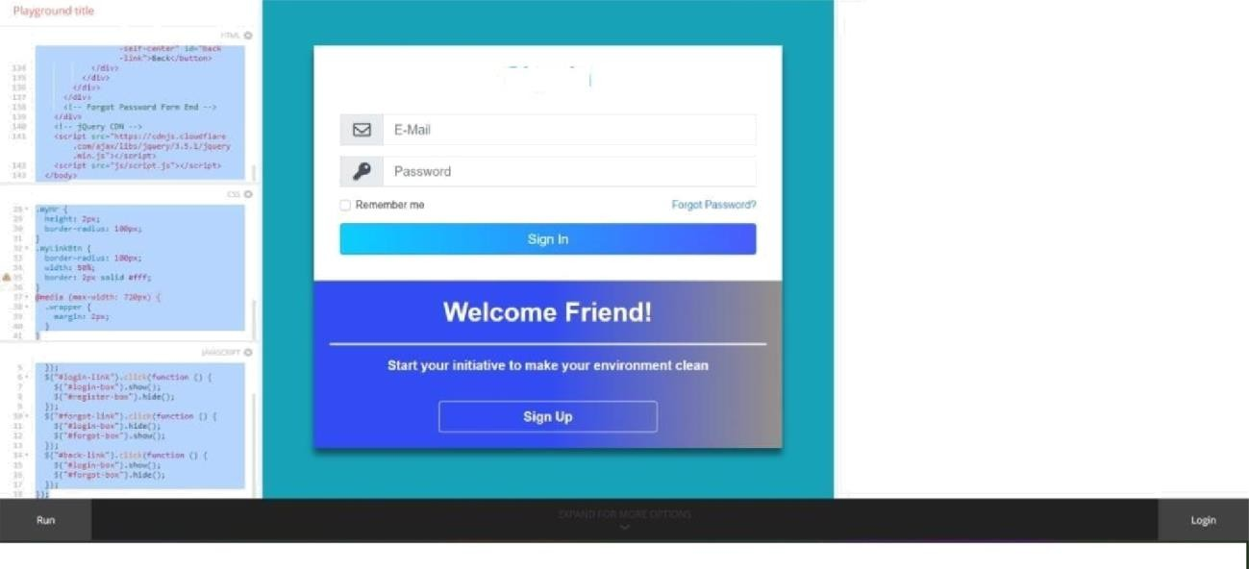

Signin

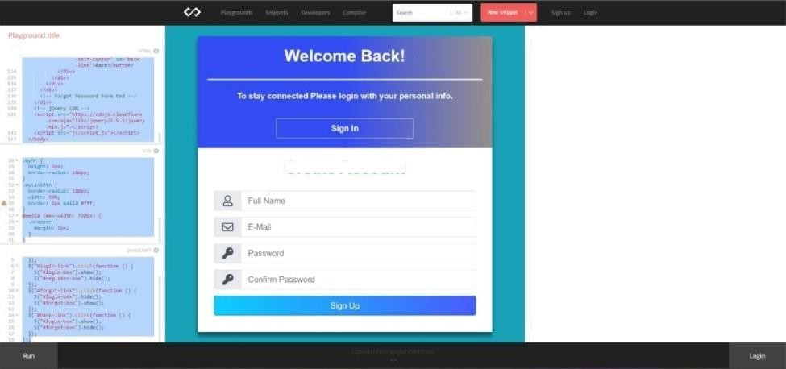

CreateAccount